**Line Following Vehicle for Blind People**

**1. Introduction:**

The Line Following Vehicle for Blind People is designed to assist visually impaired individuals in navigating predefined routes using a mobile application. This project utilizes an ESP32 microcontroller and IR sensors for efficient line tracking.

**2. Objectives:**

Develop a line-following mechanism using IR sensors. Implement voice command recognition through an Android mobile app. Enable the user to select destinations via voice commands. Integrate the ESP32 microcontroller for motor control based on sensor inputs.

**3. Components Used:**

* ESP32 microcontroller
* IR sensors (2 front, 2 left, 2 right)
* Motor driver
* Chassis and wheels
* Android mobile phone for voice commands

**ESP32 Micro Controller**

The ESP32 is a series of low-cost, low-power system-on-chip microcontrollers with integrated Wi-Fi and dual-mode Bluetooth. It is developed by Espressif Systems. To get the most accurate and up-to-date information, I recommend checking the official Espressif Systems website or other reliable sources.

1. **Microcontroller Features:**
   * CPU architecture.
   * Clock speed and power consumption.
   * Memory specifications (RAM, Flash).
2. **Peripheral Interfaces:**
   * GPIO (General Purpose Input/Output) pins.
   * I2C, SPI, UART interfaces.
   * ADC/DAC (Analog-to-Digital Converter/Digital-to-Analog Converter).
3. **Wireless Connectivity:**
   * Details about the integrated Wi-Fi and Bluetooth modules.
   * Supported protocols and standards.
4. **Power Management:**
   * Power supply requirements.
   * Sleep modes and power-saving features.
5. **Environmental Characteristics:**
   * Operating temperature range.
   * Voltage and current specifications.
6. **Package Information:**
   * Physical dimensions.
   * Pin configurations.
7. **Electrical Characteristics:**
   * Electrical specifications for various operating conditions.
8. **Functional Description:**
   * Overview of the microcontroller's architecture and components.
9. **Programming and Debugging:**
   * Information about programming interfaces.
   * Debugging support.
10. **Recommended Operating Conditions:**
    * Voltage and temperature requirements.

**IR Sensor**

The IR sensor module consists mainly of the IR Transmitter and Receiver, Op-amp, Variable Resistor (Trimmer pot), output LED along with few resistors.

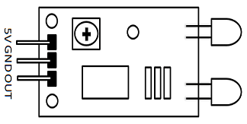

|  |  |
| --- | --- |
| **Pin Name** | **Description** |
| VCC | Power Supply Input |
| GND | Power Supply Ground |
| OUT | Active High Output |

**IR LED Transmitter**

[IR LED](https://components101.com/ir-led-pinout-datasheet) emits light, in the range of Infrared frequency. IR light is invisible to us as its wavelength (700nm – 1mm) is much higher than the visible light range. IR LEDs have light emitting angle of approx. 20-60 degree and range of approx. few centimeters to several feets, it depends upon the type of IR transmitter and the manufacturer. Some transmitters have the range in kilometers. IR LED white or transparent in colour, so it can give out amount of maximum light.

**Photodiode Receiver**

[Photodiode](https://components101.com/diodes/photodiode-pinout-datasheet) acts as the IR receiver as its conducts when light falls on it. Photodiode is a semiconductor which has a P-N junction, operated in Reverse Bias, means it start conducting the current in reverse direction when Light falls on it, and the amount of current flow is proportional to the amount of Light. This property makes it useful for IR detection. Photodiode looks like a LED, with a black colour coating on its outer side, Black colour absorbs the highest amount of light.

**Motor Driver**

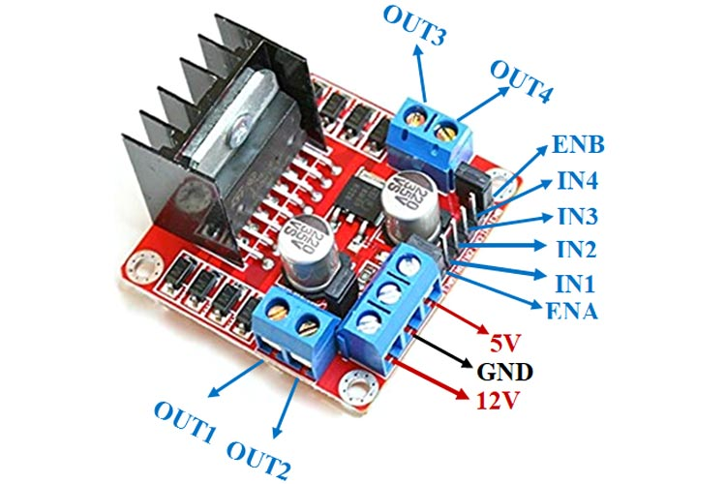

**L298N Module Pinout Configuration**

|  |  |
| --- | --- |
| **Pin Name** | **Description** |
| IN1 & IN2 | Motor A input pins. Used to control the spinning direction of Motor A |
| IN3 & IN4 | Motor B input pins. Used to control the spinning direction of Motor B |
| ENA | Enables PWM signal for Motor A |
| ENB | Enables PWM signal for Motor B |
| OUT1 & OUT2 | Output pins of Motor A |
| OUT3 & OUT4 | Output pins of Motor B |
| 12V | 12V input from DC power Source |
| 5V | Supplies power for the switching logic circuitry inside L298N IC |
| GND | Ground pin |

**Features & Specifications**

* Driver Model: L298N 2A
* Driver Chip: Double H Bridge L298N
* Motor Supply Voltage (Maximum): 46V
* Motor Supply Current (Maximum): 2A
* Logic Voltage: 5V
* Driver Voltage: 5-35V
* Driver Current:2A
* Logical Current:0-36mA
* Maximum Power (W): 25W
* Current Sense for each motor
* Heatsink for better performance

**4. System Architecture:**

* IR sensors on the front track the black line.
* Left and right sensors identify specific black patterns for station selection.
* ESP32 processes sensor data and controls the motors accordingly.

**5. Working Principle:**

* The vehicle follows the black line using front sensors.
* Voice commands from the Android app select stations (e.g., Station 1, Station 2).
* Left and right sensors detect specific patterns to determine the station.
* The vehicle moves based on the recognized pattern toward the selected station.

**6. Implementation Steps:**

* Calibrate IR sensors for line following.
* Develop a voice command recognition system on the Android app.
* Program ESP32 to interpret sensor data and control motors.
* Integrate the voice command and line-following functionalities.

**7. Challenges and Solutions:**

Challenge: Ensuring accurate line tracking.

Solution: Fine-tune sensor calibration and implement PID control.

Challenge: Reliable voice command recognition.

Solution: Use robust speech-to-text algorithms and account for various accents.

**8. Conclusion:**

The Line Following Vehicle for Blind People offers an innovative solution for visually impaired individuals to navigate predefined routes with ease. The combination of line-following technology and voice commands provides a user-friendly experience, promoting independence and mobility.

**9. Future Enhancements:**

Integration of obstacle detection sensors for improved safety. Implementation of a map-based interface on the Android app for route planning.

**10. Acknowledgments:**

Acknowledge the contributions of team members, mentors, and any external support received during the project.

**11. References:**

List any external resources, libraries, or frameworks used in the project.

**12. Appendices:**

Include detailed technical specifications, circuit diagrams, and code snippets in the appendices for reference.